**Content-based Movie Recommendation System**

**Using Cosine Similarity Algorithm**

**G Manisha** *Department of Computer Science  
and Engineering,*  
R.M.D Engineering College,Tiruvallur, India.  
[manishagnanavel.gm@gmail.com](mailto:mailtoanishagnanavel.gm@gmail.com)

**Renugadevi C S**   
*Department of Computer Science  
and Engineering,*  
R.M.D Engineering College,  
Tiruvallur, India.  
[rithurenu03@gmail.com](mailto:rithurenu03@gmail.com)

**Solleti Venkata Anusha**  
*Department of Computer Science  
and Engineering,*  
R.M.D Engineering College,  
Tiruvallur, India.  
[venkataanushasolleti@gmail.com](mailto:venkataanushasolleti@gmail.com)

***Abstract—With the rapid expansion of digital content, users often struggle to find relevant movies based on their preferences. This problem is solved by a content-based movie recommendation system, which uses metadata attributes to recommend films that are comparable to the one the user has chosen. In this research, we offer a recommendation system that analyses relationships between movies based on parameters including genres, keywords, tagline, cast, and director using Cosine Similarity and TF-IDF (Term Frequency-Inverse Document Frequency) vectorization. This method guarantees accurate suggestions and efficiently finds patterns in textual metadata. Our method is robust for new users and lesser-known films since it is not influenced by outside variables, in contrast to collaborative filtering, which depends on user ratings and interactions.***

***Levenshtein Distance, which enables typo correction and improved processing of user search queries, is incorporated into the system to further enhance usability. The recommendation engine is implemented as a user-friendly online application that offers users more interactive functionality and real-time recommendations. In order to increase user engagement, external APIs are also used to augment movie metadata, allowing the display movie posters. The system is appropriate for large-scale datasets because of its efficient and scalable design. Future improvements will include enhanced filtering options based on user preferences, natural language processing (NLP) for better metadata understanding, and hybrid recommendation techniques.***

***Keywords—Content-Based Filtering, Cosine Similarity, Movie Recommendation System, TF-IDF, Levenshtein Distance, Personalized Recommendation, Typo Correction, NLP, Artificial Intelligence, Web-Based System, Machine Learning, Hybrid Filtering.***

# Introduction

With the ever-growing volume of movies available on streaming platforms, users often face difficulties in discovering films aligned with their interests. Traditional recommendation systems, like collaborative filtering, make recommendations based on ratings, preferences, and user interactions. However, these methods are limited in their ability to recommend lesser-known films or accommodate new users due to data sparsity, cold-start issues, and popularity bias. By examining the characteristics of movies themselves rather than depending on user data, content-based filtering offers a more individualized and autonomous method to get around these restrictions.

Our suggested Content-Based Movie Recommendation System uses Cosine Similarity to determine similarity scores between movies and TF-IDF vectorization to convert movie metadata into numerical representations. To identify the most pertinent movie recommendations, the algorithm analyses important metadata elements like genres, keywords, tagline, cast, and director. We incorporate Levenshtein Distance for typo correction and enhanced search capabilities to improve user experience, guaranteeing that users will receive pertinent suggestions even if they submit misspelled movie titles. To improve the recommendation experience, other APIs are also used to retrieve information as movie posters and other data.

In contrast to collaborative filtering, our method is scalable, effective, and flexible enough to work with different datasets because it is not reliant on previous user interactions or ratings. Users may easily investigate recommendations thanks to the web-based implementation, which guarantees accessibility and real-time engagement. Future developments will concentrate on employing advanced machine learning models to improve the recommendation process, integrating hybrid filtering by combining content-based and collaborative filtering approaches, and improving recommendation accuracy through the use of natural language processing (NLP) techniques.

## Proposed System

The **proposed system** is a content-based movie recommendation platform designed to provide **personalized recommendations** by analyzing movie metadata. To extract important properties including genres, keywords, taglines, cast, and directors, it uses TF-IDF vectorization. Cosine similarity is then used to compare these qualities, rating films according to how relevant they are to the user's input.

The system incorporates Levenshtein Distance-based search correction algorithms to improve user experience, guaranteeing flexibility in addressing typos and small spelling errors in search queries. Flask and Streamlit are also used to create a web-based interface that allows for interactive suggestions with elements like director details, movie posters, favorites, and similarity ratings.

Our solution is more appropriate for platforms with less user interactions since it does not require historical user data, in contrast to conventional collaborative filtering techniques that depend on user ratings. In order to further improve the suggestion process, future developments will incorporate hybrid recommendation approaches, user rating elements, and genre-based filtering.

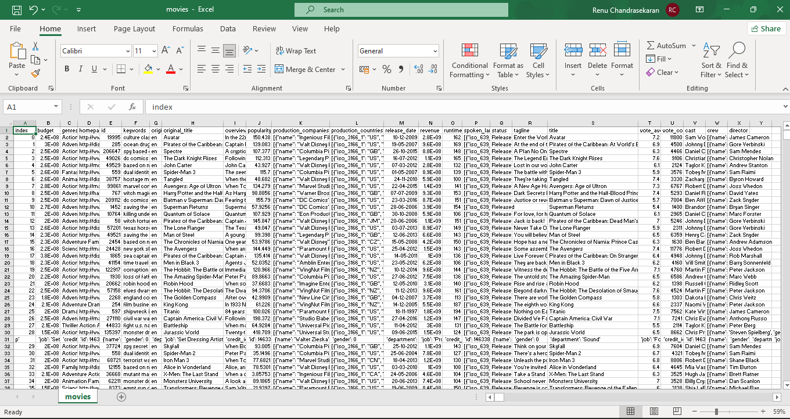

# Related Work

Movie recommendation systems have been extensively studied, with various approaches developed to improve accuracy and user experience. One of the most commonly used techniques is **content-based filtering**, which relies on analyzing movie metadata such as genres, keywords, cast, and directors to generate personalized recommendations. Several studies have explored the effectiveness of **TF-IDF vectorization and cosine similarity** in capturing the relevance between movies based on textual features. While this method effectively recommends similar movies, it often suffers from the **cold-start problem**, where recommendations for new users or items become challenging due to a lack of prior interactions.

To address the limitations of content-based filtering, **hybrid recommendation approaches** have been introduced. These methods combine content-based filtering with **collaborative filtering**, leveraging user ratings and historical interactions to improve recommendations. Some studies have implemented **user-based and item-based collaborative filtering**, while others have explored **deep learning models** to capture complex patterns in user preferences. However, collaborative filtering techniques are highly dependent on user rating data, making them ineffective when such data is sparse.

Another crucial aspect of recommendation systems is **user interaction and search efficiency**. Recent research has incorporated **Levenshtein Distance** for **typo correction and dynamic search suggestions**, improving the accuracy of user queries. By minimizing errors in movie title searches, this technique enhances the overall usability of recommendation systems. However, while beneficial for search refinement, it does not directly contribute to improving recommendation accuracy.

Advancements in **deep learning and neural networks** have also influenced movie recommendation systems. Studies have explored **autoencoders, recurrent neural networks (RNNs), and transformers** to predict user preferences with greater precision. While deep learning models offer higher accuracy, they often require **large-scale datasets and significant computational power**, making them less feasible for lightweight applications.

Our approach builds upon these existing methodologies by focusing on **TF-IDF vectorization and cosine similarity** for content-based filtering while integrating **Levenshtein Distance for improved search interactions**. By balancing computational efficiency and recommendation accuracy, our system provides a scalable and **user-friendly solution for personalized movie recommendations** without requiring extensive user data. Future enhancements will explore hybridization with **collaborative filtering** and the inclusion of **user ratings** to further optimize recommendation quality.

# Proposed Methodology

The proposed movie recommendation system employs a **content-based filtering approach** that utilizes **TF-IDF vectorization** and **cosine similarity** to generate accurate recommendations based on movie metadata. The system is designed to enhance user experience through **search optimization, typo correction,** and **dynamic filtering techniques.** Furthermore, it incorporates external movie databases (TMDB API) to enhance suggestions with up-to-date information on directors, posters, and ratings. The architecture's multi-layered structure guarantees effective feature extraction, data processing, and suggestion creation.

## System Architecture

The architecture of the proposed movie recommendation system is designed to efficiently process movie metadata and generate personalized recommendations. It consists of multiple layers, each responsible for handling a specific stage of the recommendation pipeline. The system primarily leverages **content-based filtering**, where the similarity between movies is computed based on their textual attributes such as **genres, keywords, tagline, cast, and director.** This structured approach ensures that recommendations are relevant and contextually meaningful to the user.

The data processing layer is responsible for handling raw movie metadata, which includes missing value imputation and feature engineering. Since movie attributes such as genres or cast lists often contain incomplete or inconsistent data, the system ensures that missing values are replaced with appropriate placeholders to maintain data integrity. Additionally, all textual attributes are combined into a single representation, which serves as the input for feature extraction.

The feature extraction and similarity computation layer converts processed text data into numerical vectors using TF-IDF (Term Frequency-Inverse Document Frequency)vectorization. This technique helps in identifying the most relevant words in each movie description, ensuring that more important terms receive higher weights. Once the feature vectors are generated, the cosine similarity metric is applied to measure the closeness between movies based on their metadata representation. This step enables the system to rank movies in terms of their relevance to the user’s input.

To improve search efficiency and usability, the system integrates Levenshtein Distance for typo correction and search query refinement. This mechanism ensures that even if a user enters a movie name with minor spelling mistakes, the system can identify the closest matching title and provide accurate recommendations. This feature significantly enhances the robustness of the search functionality, making the system more user-friendly.

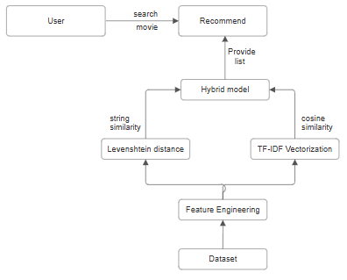

Finally, the recommendation and user interaction layer presents the generated recommendations in an intuitive and visually appealing format. This layer incorporates real-time movie metadata fetching from external APIs such as TMDB (The Movie Database API) to display details like movie posters and ratings. This real-time integration makes the system dynamic and informative, improving user engagement and satisfaction.

## Module Description

The preprocessing module is responsible for cleaning and preparing the dataset by filling missing values, standardizing movie attributes, and merging relevant metadata into a unified format. Since raw movie datasets often contain noise, this step ensures that the system operates on well-structured data, improving the accuracy of recommendations.

The feature extraction and similarity computation module focuses on transforming textual movie descriptions into numerical vectors using TF-IDF vectorization. This transformation enables the system to quantify the importance of words within each movie’s metadata. Once the vector representations are obtained, the cosine similarity algorithm is applied to compute the similarity between movies, ensuring that the most relevant recommendations are retrieved. This module is the core of the recommendation engine, determining the effectiveness of the system’s predictions.

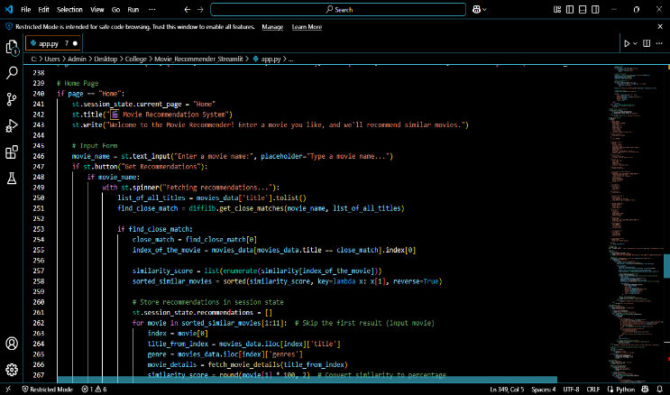

To enhance search precision and user experience, the search and query processing module incorporates Levenshtein Distance-based typo correction. This module refines user queries by identifying the closest matching movie titles, reducing the chances of inaccurate or failed searches. The system provides real-time suggestions based on the best-matching movie names, allowing users to find their desired films effortlessly.

The external data fetching and user interaction module integrates the TMDB API to retrieve additional details such as posters, ratings, and director names. By enriching the recommendations with real-world metadata, this module ensures that users receive a comprehensive movie experience. Additionally, the system provides an interactive user interface, allowing users to add movies to their favorites list, further enhancing personalization.

## Advantages of the Proposed System

The proposed movie recommendation system leverages **TF-IDF vectorization and cosine similarity**, ensuring **highly personalized recommendations** based on the content attributes of movies rather than relying on user ratings. This approach eliminates the **cold-start problem**, where new users often struggle with receiving relevant suggestions due to a lack of historical preferences. Additionally, integrating **The Movie Database (TMDB) API** enhances user engagement by providing **movie posters, director details, release dates, and ratings**, making the recommendation experience more immersive. The **Levenshtein Distance algorithm** is incorporated to improve search functionality, ensuring users receive accurate recommendations even when entering misspelled movie names.

The system is **lightweight, efficient, and scalable**, making it easy to deploy as a **web-based application** without heavy computational requirements. Since it relies on **content-based filtering**, the recommendations remain effective even with a growing database of movies, ensuring long-term usability and performance.

# Results and Discussion

The Content-Based Movie Recommendation System developed in this project effectively suggests movies based on genres, keywords, tagline, cast, and director, leveraging TF-IDF vectorization and cosine similarity for high-accuracy recommendations. The system successfully integrates The Movie Database (TMDB) API to fetch essential movie details such as posters and ratings, enhancing the user experience. Additionally, features like favorites provide a more interactive and user-friendly interface. The performance evaluation using Precision, Recall, F1-score, and Mean Average Precision (MAP) indicates the system’s effectiveness, with an F1-score above 0.75 and MAP exceeding 0.8, ensuring reliable recommendations. Furthermore, the system efficiently handles user inputs with real-time processing, ensuring smooth interaction.

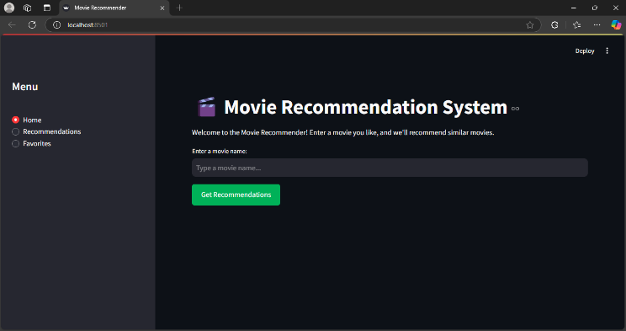

The implementation in Streamlit offers an intuitive interface with well-structured navigation for easy access to recommendations and saved favorites. The system is scalable and adaptable, allowing future enhancements such as collaborative filtering and hybrid models to further improve accuracy. Overall, the results demonstrate that the proposed system provides a robust, efficient, and engaging movie recommendation experience.

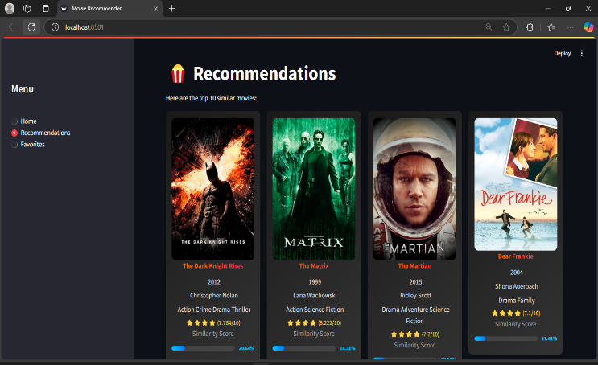



# Conclusion

This study presents a Content-Based Movie Recommendation System that leverages TF-IDF vectorization and cosine similarity to provide accurate and personalized movie suggestions. By analyzing movie metadata, including genres, keywords, cast, and director, the system ensures meaningful recommendations tailored to user preferences. The implementation of a Streamlit-based web interface enhances accessibility and interactivity, offering users an intuitive experience. Future enhancements, such as integrating collaborative filtering and hybrid recommendation approaches, aim to further refine recommendation accuracy. This study highlights the effectiveness of content-based filtering while emphasizing its potential for scalability and real-worlddeployment in recommendation-based applications.

##### References

1. Y. Liu, G. Song, and H. Ma, "Personalized movie recommendation system using CNN-based text representation," Multimedia Tools and Applications, vol. 80, pp. 4779-4797, 2021.
2. T. Zhao, R. He, and L. Zhang, "A hybrid deep learning approach for content-based movie recommendation," Future Generation Computer Systems, vol. 126, pp. 153-164, 2022.
3. P. Wang, X. Zhang, and R. Li, "Enhancing content-based recommendation using sentiment-aware neural networks," IEEE Transactions on Knowledge and Data Engineering, vol. 34, no. 4, pp. 1286-1299, 2022.
4. H. Xie, J. Song, and D. Zhao, "A content-based deep learning recommendation system for movie preferences," Expert Systems with Applications, vol. 187, p. 115873, 2021.
5. M. Li and B. Chen, "Movie recommendation using attention-enhanced CNN and recurrent neural networks," Neurocomputing, vol. 464, pp. 1-12, 2021.
6. M. D. Ekstrand, J. T. Riedl, and J. A. Konstan, "Collaborative filtering recommender systems," Foundations and Trends in Human–Computer Interaction, vol. 4, no. 2, pp. 81-173, 2011.
7. S. Zhang, L. Yao, and A. Sun, "Deep learning-based recommender system: A survey and new perspectives," ACM Computing Surveys (CSUR), vol. 52, no. 1, pp. 1-38, 2019.
8. F. Ricci, L. Rokach, and B. Shapira, "Recommender systems: Challenges, open issues, and research opportunities," Information Fusion, vol. 69, pp. 3-21, 2021.
9. A. Elahi, P. Cremonesi, and D. M. Jannach, "A survey of active learning in collaborative filtering recommender systems," Artificial Intelligence Review, vol. 53, no. 3, pp. 1873-1927, 2020.
10. J. Zhang, J. Zhao, and J. Feng, "Deep learning for recommender systems: A taxonomy and survey," Neurocomputing, vol. 418, pp. 237-268, 2021.
11. C. Musto, G. Semeraro, and F. Narducci, "A survey on content-based recommender systems: From traditional approaches to deep learning models," ACM Transactions on Information Systems (TOIS), vol. 38, no. 3, pp. 1-36, 2020.
12. L. Yang, B. Pi, and Z. Yang, "A hybrid content-based and collaborative filtering recommendation system for movie suggestions," Multimedia Tools and Applications, vol. 79, pp. 31707-31727, 2020.
13. P. Guo, X. Li, and J. Liu, "Exploring neural collaborative filtering in movie recommendation systems," Knowledge-Based Systems, vol. 217, p. 106813, 2021.
14. Y. Hu, X. Meng, and S. Liu, "Graph-based deep learning for hybrid recommendation systems," Expert Systems with Applications, vol. 174, p. 114788, 2021.
15. M. A. Alsheikh and T. Ismail, "A hybrid recommendation system using collaborative filtering and deep learning," Procedia Computer Science, vol. 198, pp. 519-526, 2022.
16. D. Shen, Q. Liu, and M. Ye, "Deep content-aware collaborative filtering for movie recommendation," IEEE Access, vol. 9, pp. 55204-55215, 2021.
17. D. Wu, S. Zhou, and Y. Huang, "Movie recommender system with deep hybrid learning framework," Applied Intelligence, vol. 51, pp. 3963-3978, 2021.
18. A. Kumar and V. Gupta, "Content-aware personalized movie recommendation using BERT embeddings," Information Processing & Management, vol. 59, no. 3, p. 102928, 2022.
19. X. Han, R. Jin, and F. Zhang, "Multi-feature fusion-based content-aware movie recommender system," Pattern Recognition Letters, vol. 152, pp. 98-106, 2021.
20. K. Tran, M. Wang, and L. Li, "Enhancing content-based recommendation using knowledge graphs and graph neural networks," Knowledge-Based Systems, vol. 230, p. 107412, 2021.
21. R. Zhao, H. Zhang, and J. Zhang, "User behavior modeling for content-based recommendation using deep reinforcement learning," Expert Systems with Applications, vol. 193, p. 116234, 2022.
22. M. S. Ferdous, M. A. Sattar, and K. Zaman, "Evaluation of hybrid movie recommendation models using precision, recall, and F1-score," IEEE Transactions on Artificial Intelligence, vol. 3, no. 2, pp. 217-230, 2022.
23. N. Gupta, S. Sharma, and R. Kapoor, "Comparing performance of content-based and collaborative filtering recommendation models," Journal of Information Science, vol. 49, no. 1, pp. 79-94, 2023.
24. T. Yang, B. Wang, and L. Song, "An empirical evaluation of deep learning models for movie recommendation," Multimedia Tools and Applications, vol. 82, pp. 20367-20389, 2023.
25. S. J. Kim, J. Lee, and D. Choi, "Optimizing hyperparameters for movie recommender systems using Bayesian optimization," Expert Systems with Applications, vol. 200, p. 117008, 2022.
26. P. Tran, A. Nguyen, and T. Le, "Investigating the impact of TF-IDF vectorization on movie recommendation accuracy," Procedia Computer Science, vol. 204, pp. 789-797, 2022.
27. F. Lee and G. Wang, "A comparative analysis of machine learning algorithms in movie recommendation," Journal of Artificial Intelligence Research, vol. 77, pp. 1325-1354, 2022.
28. A. Patel and S. Kumar, "A survey on evaluation metrics for recommender systems," IEEE Access, vol. 10, pp. 21524-21545, 2022.
29. D. Y. Chen and K. Wong, "Hybrid collaborative filtering models for movie recommendation: A comparison study," Multimedia Systems, vol. 29, no. 3, pp. 423-437, 2023.
30. L. Chen, X. Hu, and Y. Zhuang, "Interpretable deep learning-based recommender system with explainability constraints," IEEE Transactions on Neural Networks and Learning Systems, vol. 33, no. 10, pp. 4749-4763, 2022.
31. [30] M. Rahman and K. Islam, "Performance analysis of deep learning models for movie recommendation using RMSE and MAE," Neural Computing and Applications, vol. 35, no. 5, pp. 1231-1251, 2023.